**POSTMAN TEST FOR DELETE METHOD**

I used the postman to send a request for the delete method and it worked perfectly

Below is the php code for using the delete method and screenshot of the postman test: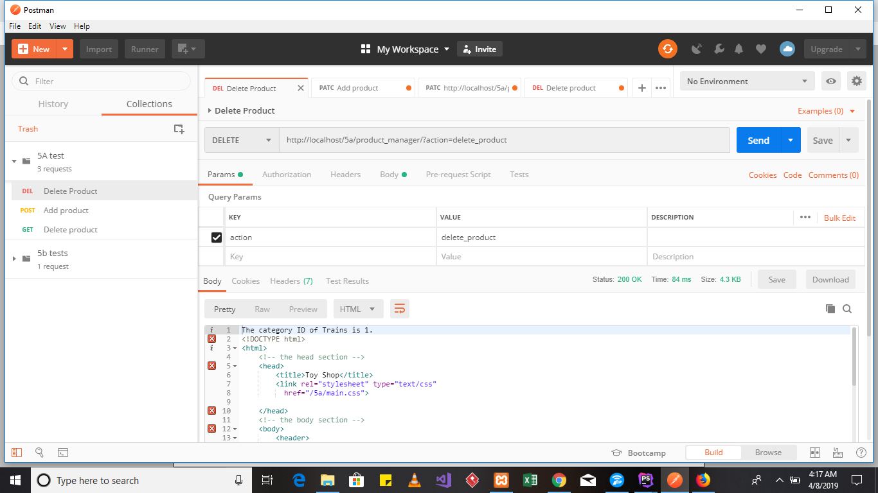

And it shows a status of 200 which means ok.

And below contains the screenshot for the delete method in php:

